Family & Friends Test – Oct 2022

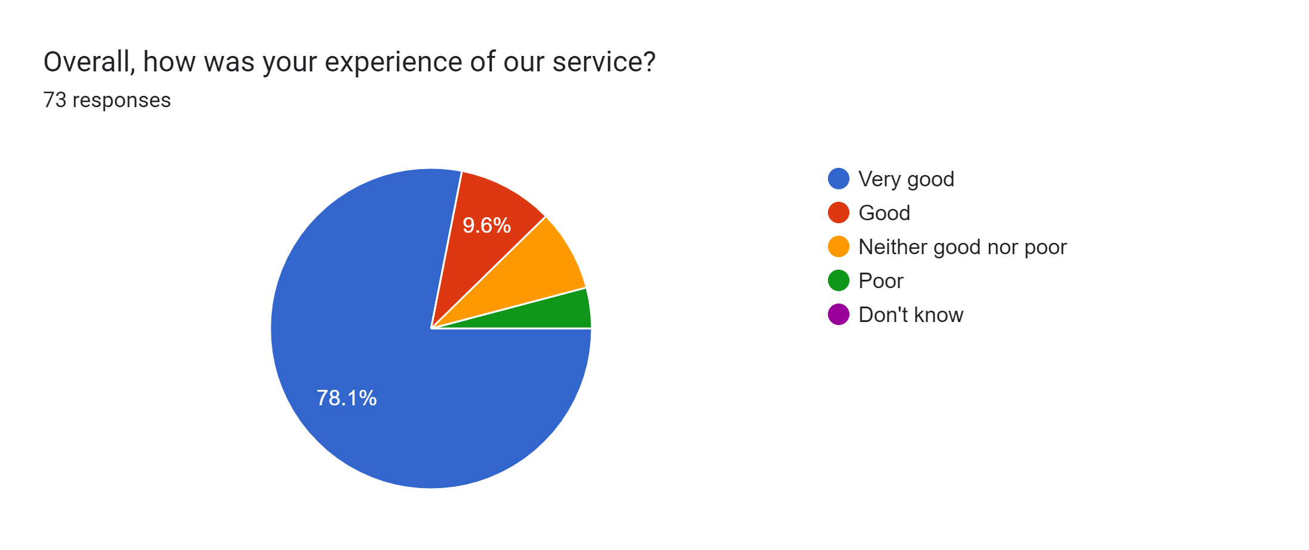

Satisfaction Score: 87.7%

