Family & Friends Test
Mar 2023

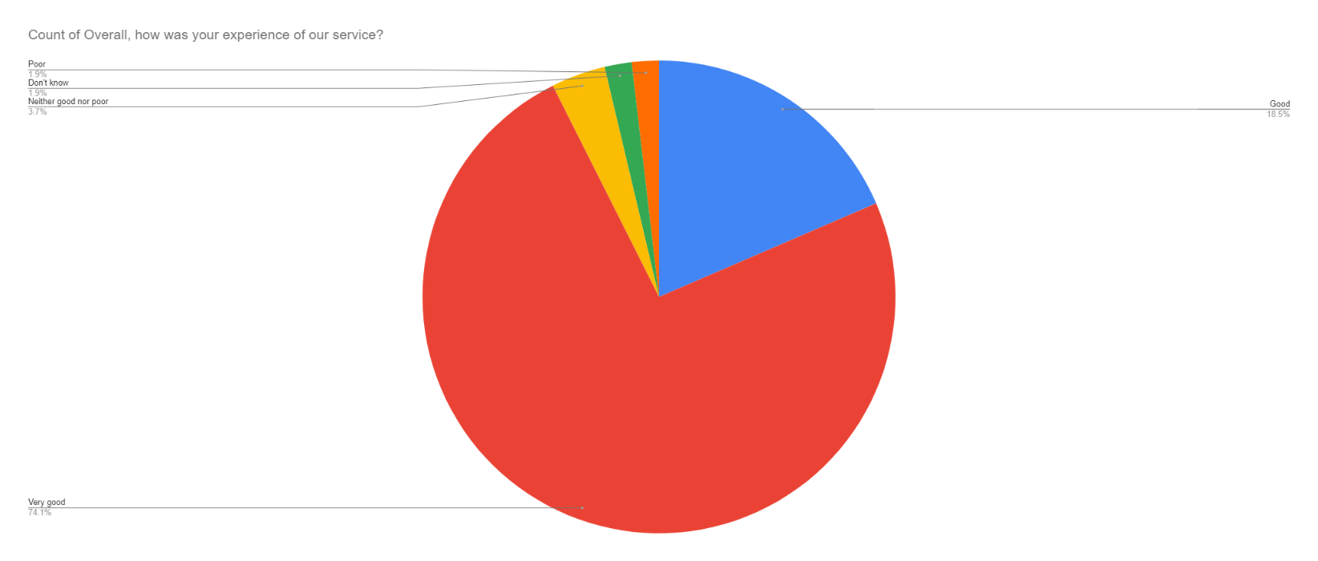

Satisfaction Score: 92.6%

