Family & Friends Test
April 2023

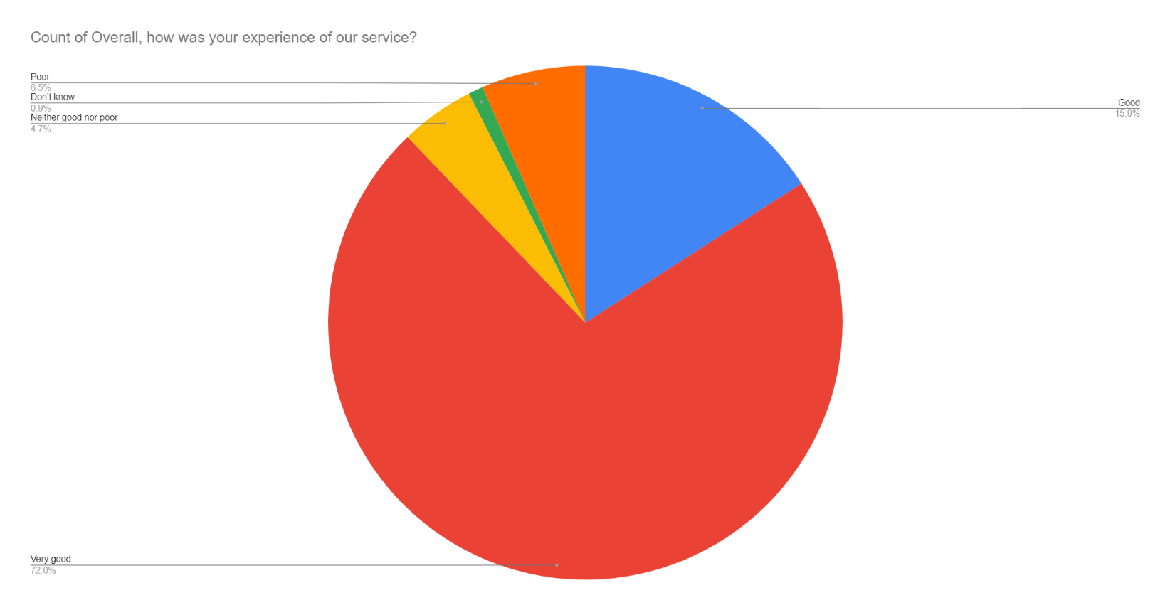

Satisfaction Score: 87.9%

