Family & Friends Test
June 2023

Count of overall, how was your experience with our service
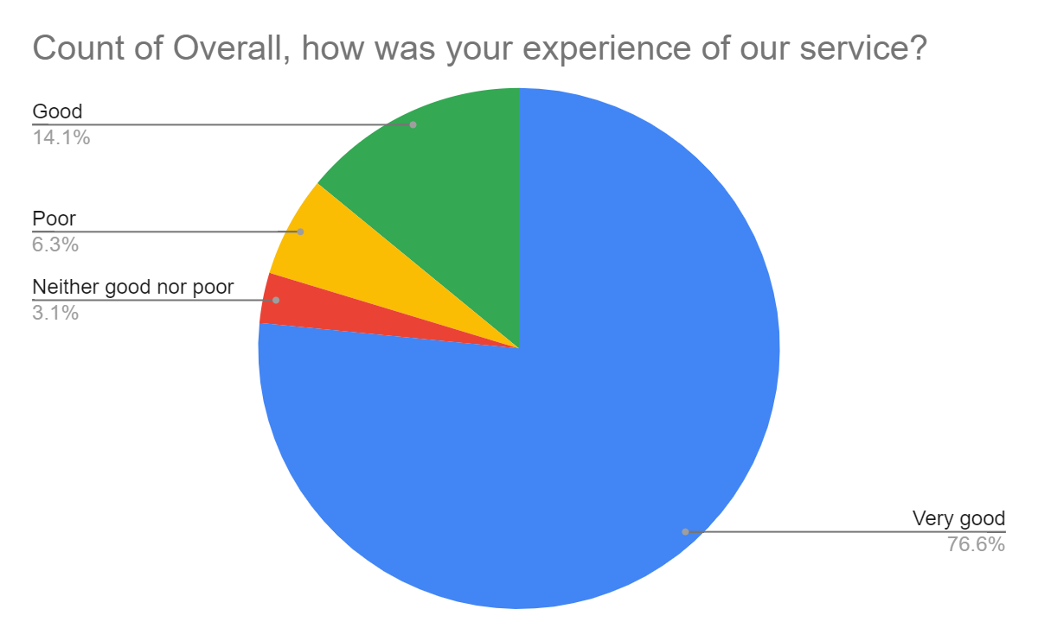

Satisfaction Score: 90.62%

