Family & Friends Test
August 2023

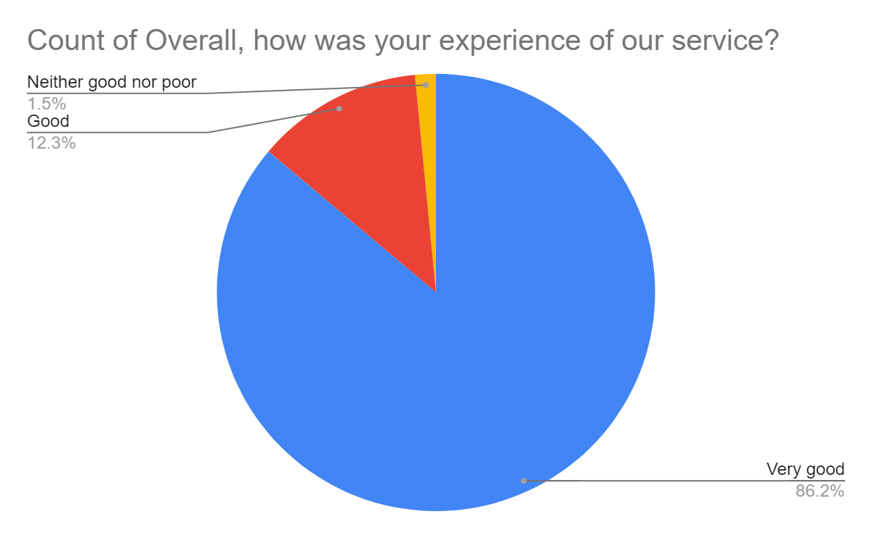

Satisfaction Score: 98.5%

