Family & Friends Test
September 2023

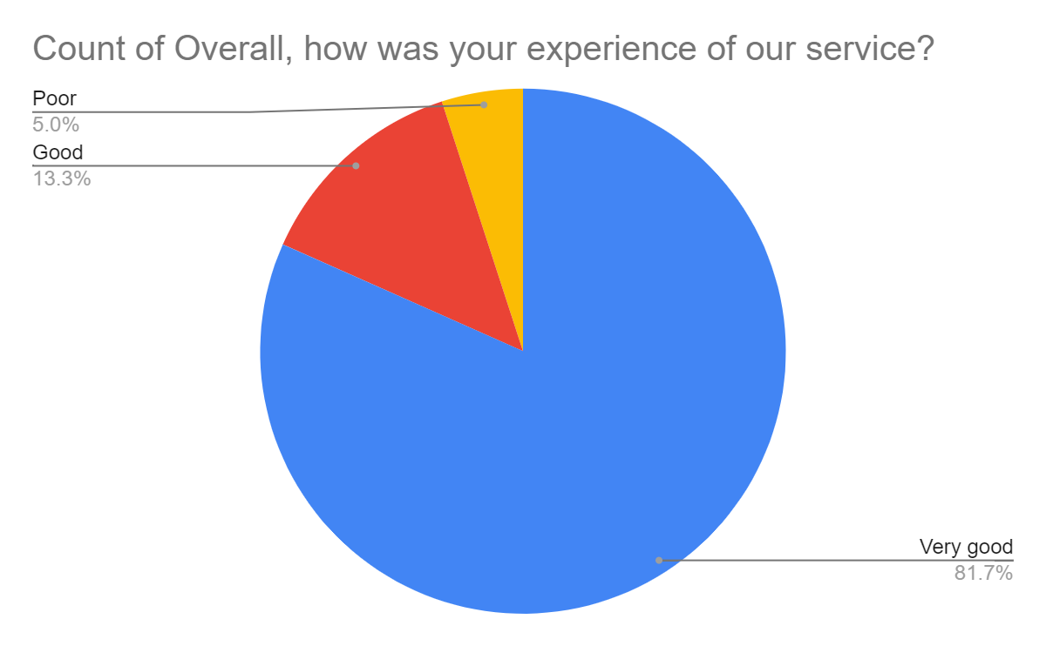

Satisfaction Score: 95.0%

