Family & Friends Test
November 2023

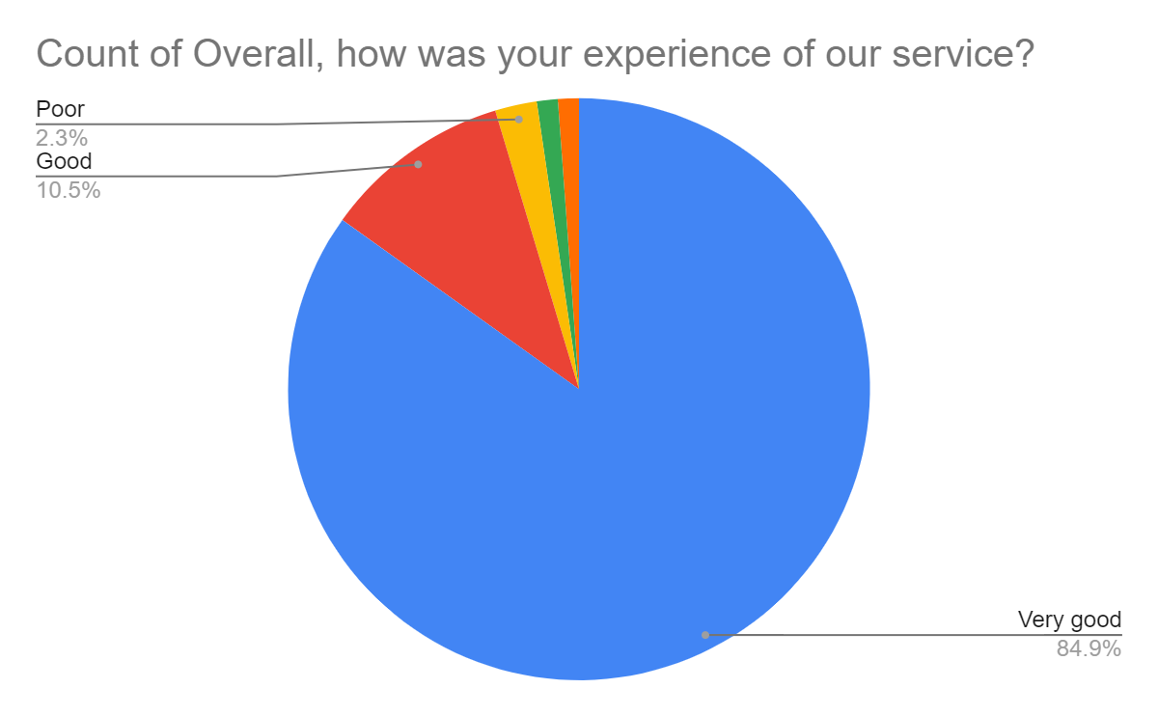

Satisfaction Score: 95.4%

