Family & Friends Test
December 2023

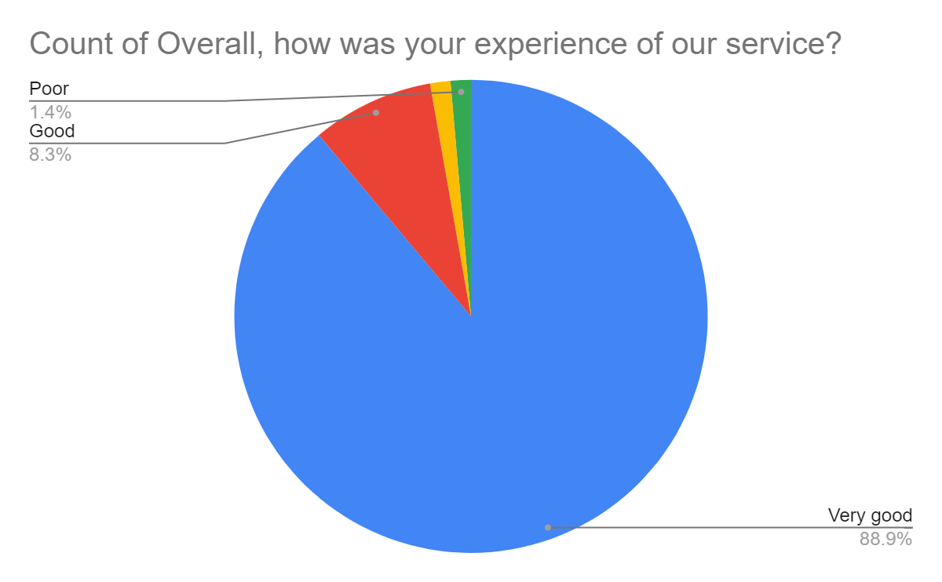

Satisfaction Score: 97.2%

