Family & Friends Test
January 2024

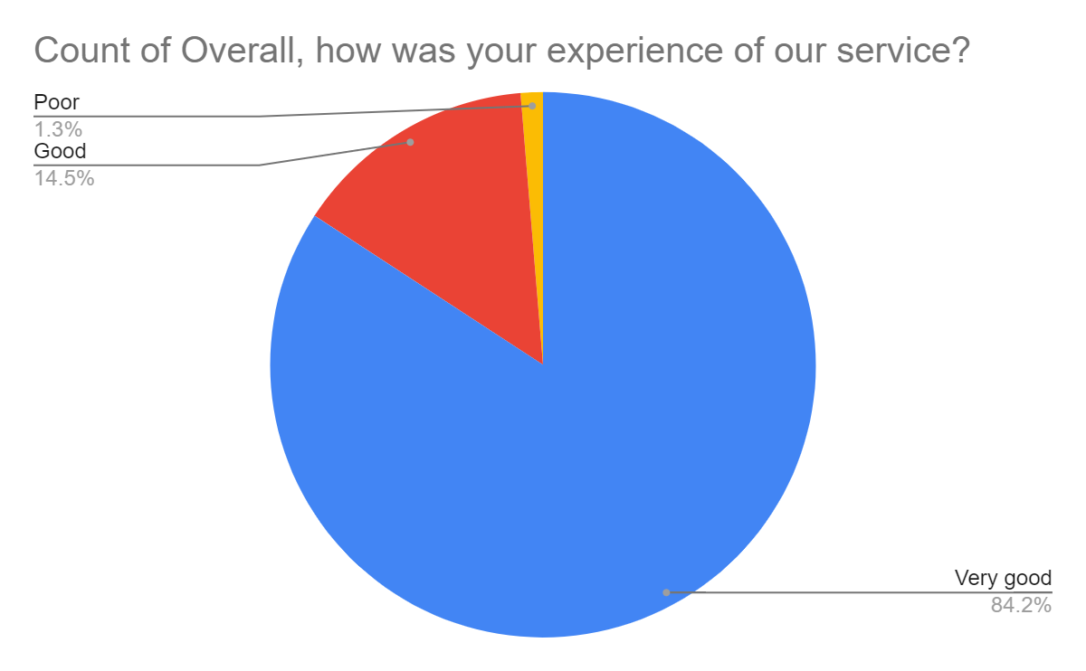

Satisfaction Score: 98.7%

