
South Bucks Hospice
at Butterfly House
Outpatient care enhancing quality of life

About Us

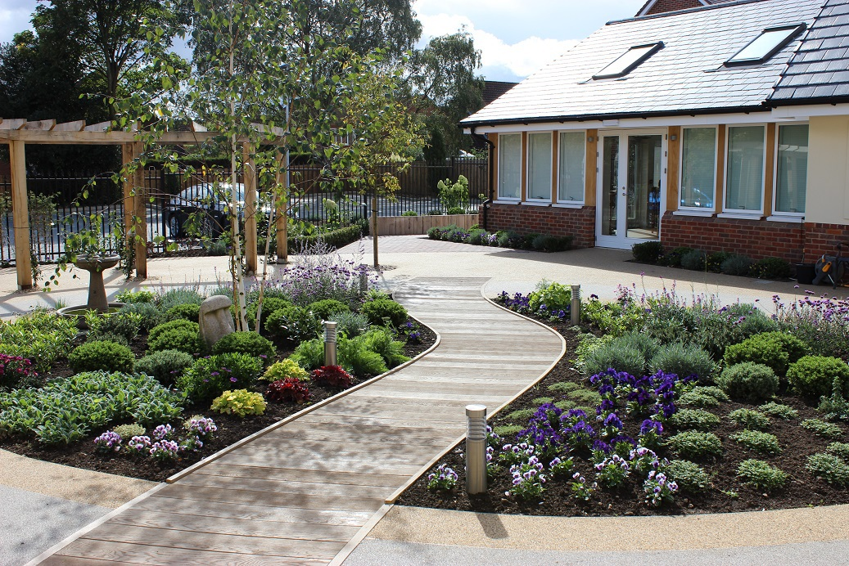
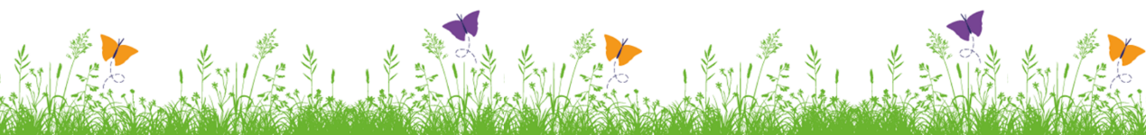

Contents
Welcome …………………………………………………………………………………………………... 3
Nursing care ……………………………………………………………………………………………… 4
Palliative Care …………………………………………………………………………………………… 5
Emotional support …………………………………………………………………………………… 6
Spiritual Care …………………………………………………………………………………………… 6
Physiotherapy …………………………………………………………………………………………… 7
Complementary Therapies ……………………………………………………………………….. 8
Lymphoedema Clinic …………………………………………………………………………………. 9
Support for Families and Carers ……………………………………………………………….. 10
Emotional and Practical Support for Carers ……………………………………………… 10
Practical Support for Carers ……………………………………………………………………… 10
Support Groups ……………………………………………………………………………………….. 11
Frequently asked questions …………………………………………………………………..12/13
Ways you can help us ……………………………………………………………………………….. 14
Making a gift ……………………………………………………………………………………………… 15

Welcome
Welcome to South Bucks Hospice at Butterfly House.
We are a local charity dedicated to providing the highest standard of care and support to patients, families and carers affected by a life limiting or a life-threatening illness.
We are a day hospice based in High Wycombe, founded in 1986. We provide a holistic approach to palliative care, meaning that we look after the whole person and their family.
All our services are free of charge to those we help. We receive less than 4% of our income from the NHS and so we are only able to offer our services free of charge thanks to the generosity of our supporters.
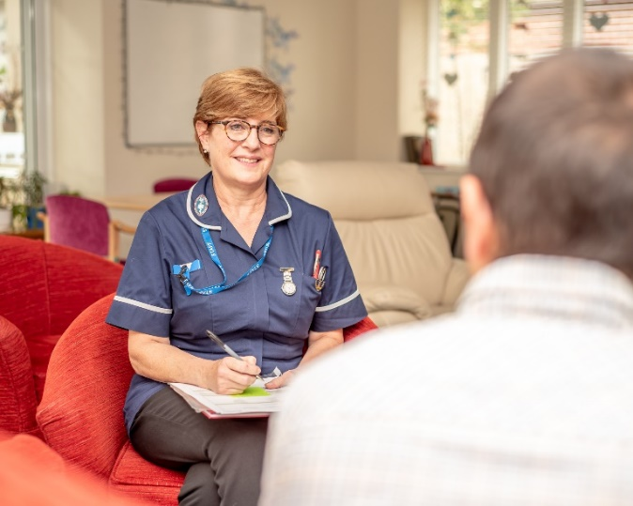

“There is always someone here to talk to. This has made all the difference to my life”

Nursing care

As your local friendly hospice, we aim to provide you with excellent palliative care and intervention whilst you are well enough to attend our services.
Once referred to us, you will be invited for an initial assessment which will help us identify your particular palliative symptoms. We will provide guidance and will liaise across the different healthcare services, such as your GP, community specialist teams, hospital specialists’ etc. to ensure you are receiving the best care possible.
Within this assessment, we will be able to sign post you to our relevant services at South Bucks Hospice, so that we can help you live a good quality of life.
Our on-going assessments will enable us to review the care we are providing, so that we can ensure that you are receiving the optimum level of care to manage your symptoms.
We understand the importance of our patients feeling comfortable while they are having a treatment. If you would like a chaperone to be present, please speak to a member of the nursing team who will be able to arrange this for you.
We also provide groups that you may find helpful; please see page 11.
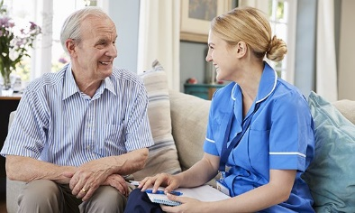

Providing you with care, comfort and support

Palliative Care
Palliative care helps to improve and enhance the quality of life of patients who have a serious or life-limiting condition.
Our clinical team are experienced in caring for patients with life-limiting illnesses. Together we will assess your needs, find out what particular concerns you may have and discuss your expectations.
As a team we will work with you to create a tailored care plan which we will continually assess and develop with you according to your on-going needs. Our multidisciplinary team comprises nurses, psychotherapists and counsellors, a physiotherapist, lymphoedema and complementary therapists as well as a patient advocate and the support of many expert volunteers.


Improving quality of life

Emotional Support
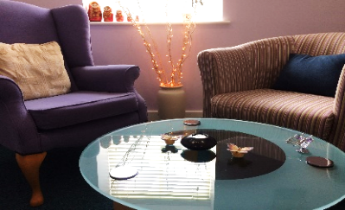
A life-limiting or life-threatening illness is emotionally and mentally challenging. Our team of professional psychotherapists and counsellors will help you and your family come to terms with your illness, helping you to understand your emotions. We do not stop caring for you during treatment or after remission or bereavement, but work with you to support you, your family and carers as you process and come to terms with what you have experienced. We help you to rebuild your life.
We offer:
- Individual therapy
- Couple therapy
Spiritual Care
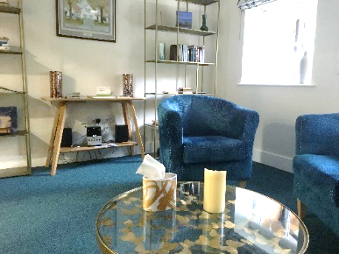
Spiritual beliefs and faith can be a source of strength.
Often when a person is diagnosed with a life-limiting or life-threatening illness, they may seek solace in a faith that they follow or have lost. Living with a serious illness can cause you to question your beliefs. We provide support for our patients, their families and carers in search of meaning and hope. The most common question is “why?”. Our spiritual care team are here for people of all faiths or none.

On-going emotional support for you, your family and carers

Physiotherapy

Physiotherapy is the science of movement. Following an assessment, a structured plan and course of treatment will be tailored to your needs. We will work with you to regain as much mobility and strength as we can. Having a structured plan will also help with your emotional wellbeing as you work towards regaining as much independence as possible.

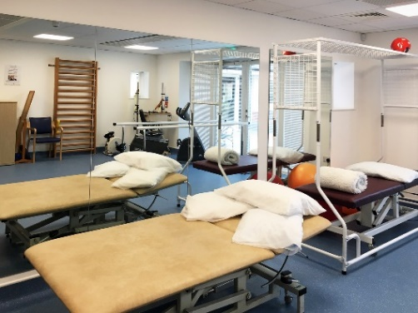
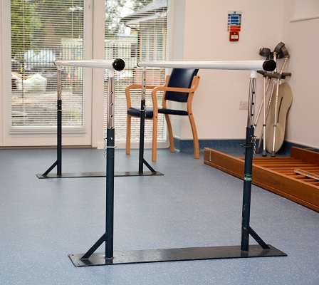
We are also able to support patients with more complex neurological needs, including pain relief whilst helping to improve mobility and balance.

Acupuncture / auricular therapy
We offer a holistic approach to patients’ needs and are pleased to offer acupuncture and auricular therapy alongside physiotherapy. These therapies help to treat the side effects of chemotherapy. This holistic approach is linked to supporting physical and emotional needs which help in supporting people regain and maintain an optimised quality of life.
Helping to maintain your independence and attain the best quality of life

Complementary Therapies
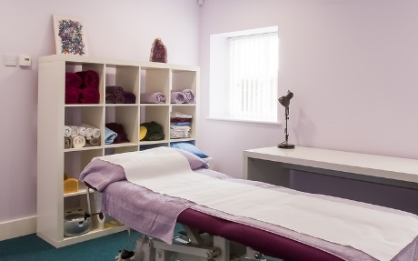
Complementary therapies can help you feel calm and relaxed and may also provide relief from pain, anxiety, depression, nausea, stress and promote better sleep.

Complementary therapies are not designed to replace your medication.
Complementary therapies are available to our patients and their carers.
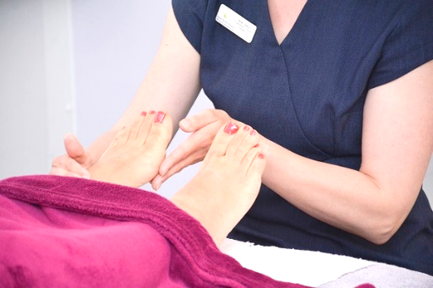
We offer:
- Acupuncture
- Aromatherapy Massage
- Reflexology
- Beauty Therapy
- Mindfulness Classes
- Indian Head Massage
- Massage (Full Body massage or targeted areas)

All our complementary therapists are fully qualified in their field, and treatments will be given depending on the outcome of your initial nurse consultation.

Relax, look good, feel good

Lymphoedema Clinic
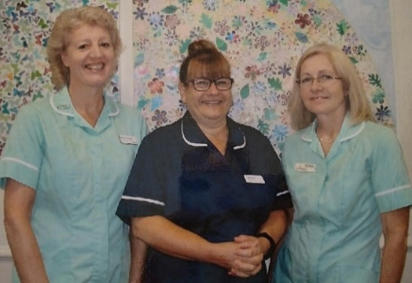

Lymphoedema is a chronic condition which causes a build-up of fluid in tissues. It can occur in any part of the body but is most common in the arms or legs. Lymphoedema can cause an aching or heavy feeling in the part of the body affected leading to problems with mobility.
Through proper management, our lymphoedema therapists can help you to regain mobility and ease discomfort. We offer specialist lymphoedema therapy using a variety of techniques to stimulate the flow of fluid through the lymphatic system to reduce swelling.
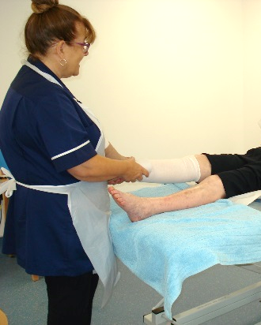
Our treatments include:
- Manual Lymphatic Drainage
- Compression
- Skin Care
- Exercise

Regain mobility and ease discomfort

Support for Families and Carers

We offer support and therapy to our patients’ families and carers.
It is important that you take care of your own health, even if you are busy looking after someone else's health. Being healthy is not only important for you, but it helps the person you care for too.

Emotional Support for Carers
At Butterfly House we extend all supportive therapies available to our patients, to their families and carers as well.

Practical Support for Carers
When caring for someone, many practical issues can be put to one side. We will always try to help you as far as possible, but if we are unable to, we will help you get in touch with those who can.
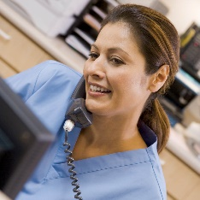

Our patients, their families and carers are at the heart of everything we do

Support Groups
Support Groups connect you with people facing the same diagnosis or similar challenges to yourself. We are currently running the following support groups:

- Breast Cancer Support Group
- Prostate Cancer Support Group
- Bereavement Support
- Advance Care Planning

We also run
- Positivity Art Group
- Ladies’ Support Group
- Men’s Support Group
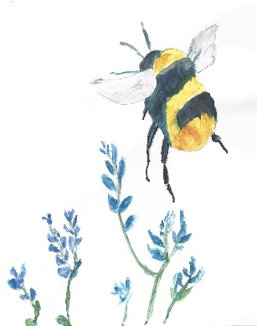
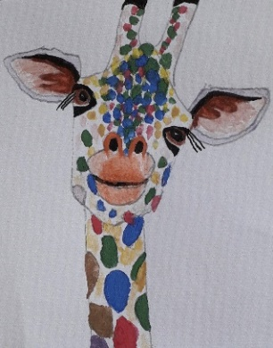
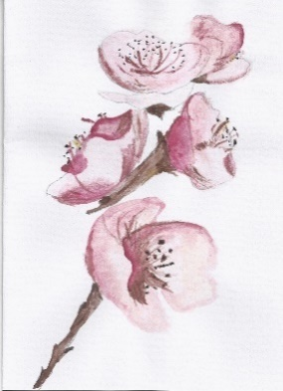

Together we are stronger
Frequently Asked Questions
Why might a day hospice be suitable for me?
Our emphasis is on helping you to continue to live at home for as long as possible. We provide specialist palliative care and support services. This care is offered by a multidisciplinary team, in partnership with other community and hospital services.
I am not dying, why am I coming to a hospice?
Not everyone who attends the Hospice is dying. We help people with a palliative care need at any stage, including whilst it may still be curative. Our Lymphoedema Clinic is a separate service offered by South Bucks Hospice which is independent from palliative care.
How much does it cost?
All our services are provided free of charge to our patients.
Do you provide patient transport?
Yes. Please call our nursing team to arrange this in advance. We are unable to provide transport for those in wheelchairs. If you require transport and you are in a wheelchair, please contact Dial a Ride or other specialist transport companies that take wheelchair users.
How often will I visit?
This depends on your treatment plan agreed between you and your nurse/therapist.
Is it like a hospital?
No. We are much more informal than a traditional hospice or hospital. You will find the hospice is a very homely and warm place.
Do you have beds?
We are a day hospice so we have no beds.

Can someone come with me?
It is possible to bring one person with you but please discuss this with whoever you are coming to see.
What if I need to cancel?
Our Policy states you can cancel up to 48 hours prior to your appointment.

Is there anything that I need to bring?
Please bring along:
- All medications you should be taking during the time you are with us. If you need help with this, please just let one of our nurses know.
- Your own walking aids. We can provide wheelchairs and frames for occasional use but it is advisable to use what you are used to.
- If you are having a bath, please bring your own toiletries or products. Please bring a change of clothes if you wish.
If you have an appointment with lymphoedema please bring:
- Your medication list.
- Your compression garments if you have already been prescribed these.
- Evidence of your Medical Exemption or your Prescription Prepayment Certificate if under 60 years old.



Ways you can help us

South Bucks Hospice is a registered charity.
We receive less than 4% of our income from the NHS.
The majority of our funding comes from the generosity of the local community. There are a range of ways you can help to support our work, including.
- Regular giving
- Legacy giving
- Fundraising events
- Shopping in and donating to our charity shops
- Volunteering

Help us raise the funds we need to run our hospice
If you are interested in supporting our work, please ask to speak to our Fundraising Manager who will be happy to talk to you about how you can help and about ways that you can give.


Your donations help us to provide a high quality, fast and responsive service

Making a gift
A regular monthly gift allows us to plan for the future as we
know we have a steady stream of income we can rely on.

Please become one of the special group of people who donate regularly to improve people’s lives by completing the enclosed Regular Giving Form.
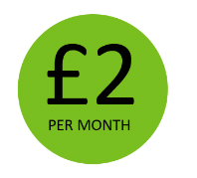
Will help towards running our Support Groups

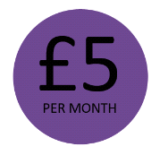
For one year could pay for a one to one session with a counsellor


For one year could pay for a two hour couples counselling session


For a year could pay for 10 lymphoedema sessions

Other ways to donate:
- By post. Please make cheques payable to South Bucks Hospice
- By calling our Fundraising team on 01494 552761 with your card details
- Through the Donate page on our website (www.sbh.org.uk/donate)
Thank you for your support

South Bucks Hospice
at Butterfly House
Outpatient care enhancing quality of life

Butterfly House, Kingswood Park,
High Wycombe, Buckinghamshire, HP13 6GR
01494 552750
info@sbhospice.org.uk
www.sbh.org.uk

Open Monday to Friday 8:30am – 4:30pm
Free parking
Our building is fully accessible and disability friendly
