Family & Friends Test
November 2024

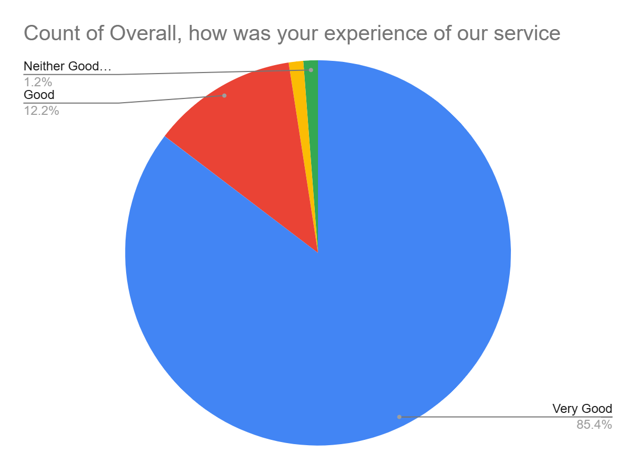

Satisfaction Score: 97.6%

