Family & Friends Test
Oct 2024

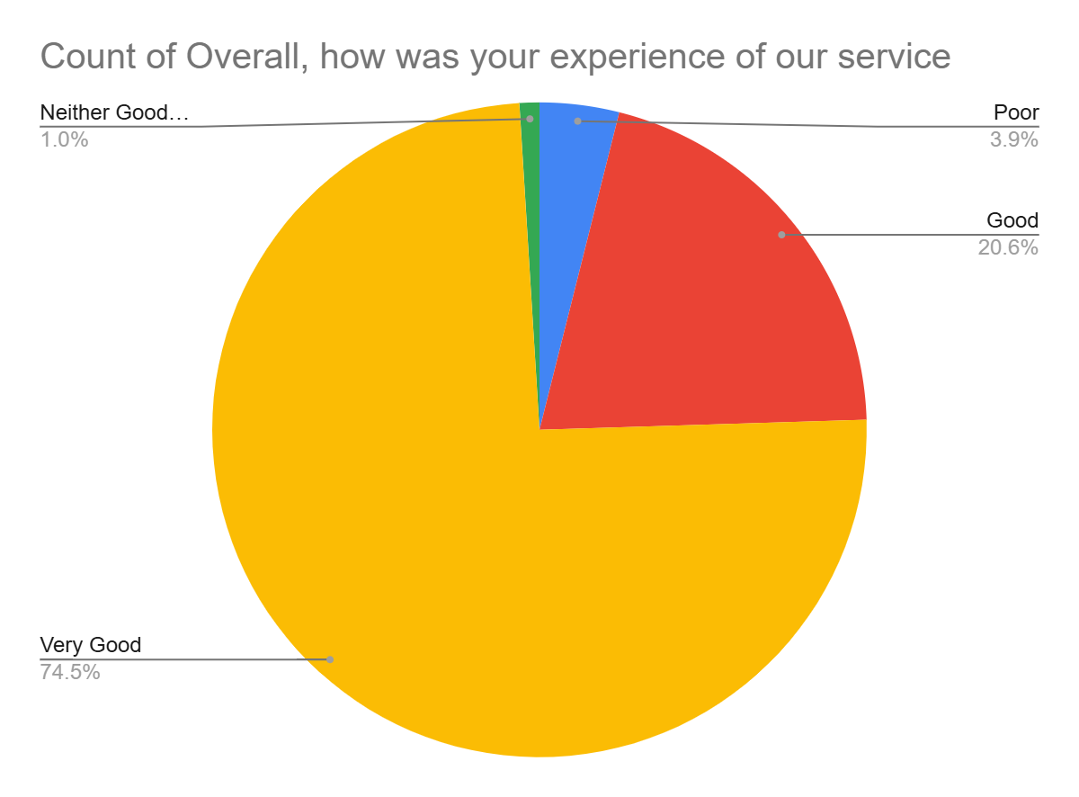

Satisfaction Score: 95.1%

