Family & Friends Test
April 25

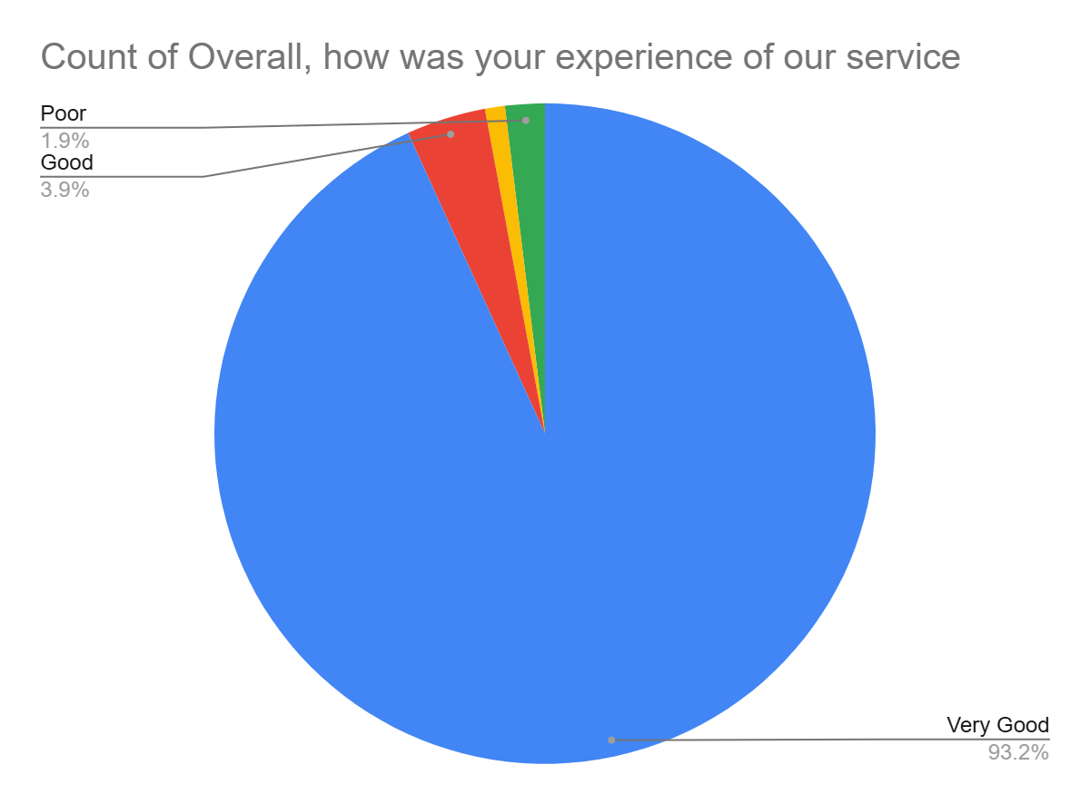

Satisfaction Score: 97.1%

