Family & Friends Test
January 25

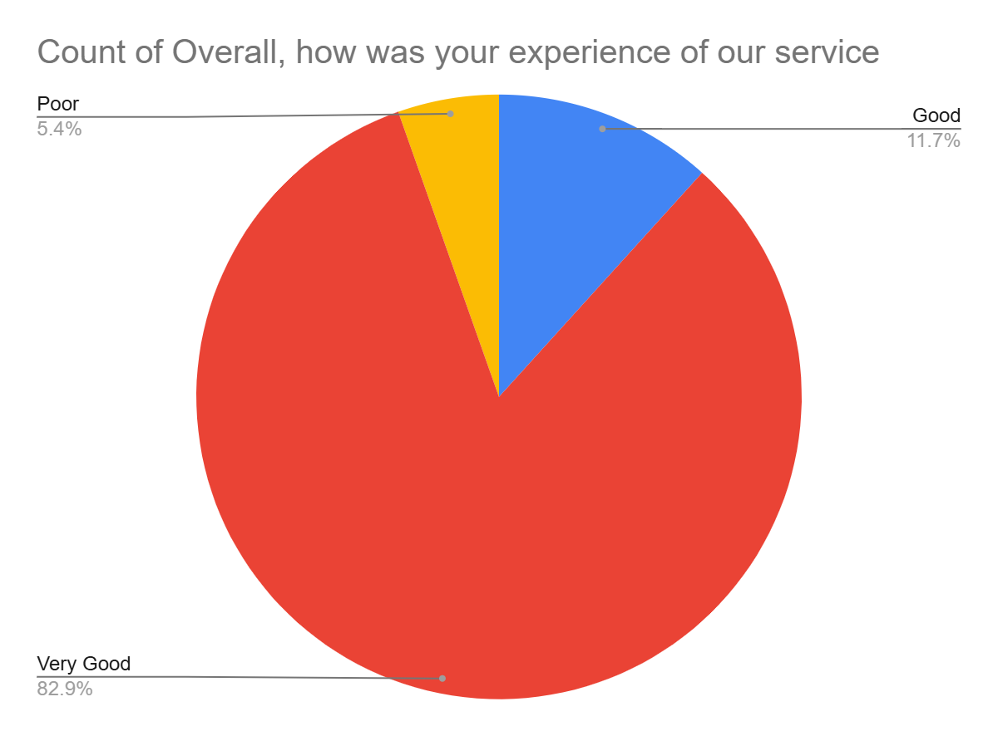

Satisfaction Score: 94.6%

